
Register Number

SRM INSTITUTE OF SCIENCE AND TECHNOLOGY
Set - B
SRM Nagar, Kattankulathur – 603203, Chengalpattu District, Tamil Nadu
College of Engineering and Technology
School of Computing
Department of Data Science and Business Systems
Academic Year: 2023-24 (Odd)

Test | : CLA-T2 | Date | : 10-10-2023
Course Code & Title | : 18CSE487T – Data warehousing and Its  Applications | Duration | : 90 Minutes
Year & Sem | : III&IV Year /V& VII Sem | Max Marks | : 50

Course Articulation Matrix:
S.No. | Course Outcome | PO1 | PO2 | PO3 | PO4 | PO5 | PO6 | PO7 | PO8 | PO9 | PO10 | PO11 | PO12 | PO13 | PO14 | PO15
1 | CO1 | 3 | - | - | - | - | - | - | - | - | - | - | - | - | - | -
2 | CO2 | 3 | - | - | - | - | - | - | - | - | - | - | - | - | - | -
3 | CO3 | 3 | - | - | - | - | - | - | - | - | - | - | - | - | - | -
4 | CO4 | 3 | - | - | - | - | - | - | - | - | - | - | - | - | - | -
5 | CO5 | 3 | - | - | 3 | - | - | - | - | - | - | - | - | - | - | -
6 | CO6 | 3 | - | - | - | - | - | - | - | - | - | - | - | - | - | -

Part - A
(5 x 1 = 5 Marks)
Instructions: Answer all
Q. No | Question | Marks | BL | CO | PO | PI Code
1 | …………………… is a good alternative to the star schema.  a) Star schema  b) Snowflake schema  c) Fact constellation  d) Star-snowflake schema | 1 | L1 | 2 | 1 | 1.6.1
2 | A fact table in the center with dimension tables directly linked to it  a) star schema  b) star flake schema  c) snowflake schema  d) constellation | 1 | L2 | 2 | 2 | 1.6.1
3 | _____describes the data contained in the data warehouse  Select one:  a) Relational data  b) Operational data  c) Informational data  d) Meta data | 1 | L2 | 3 | 2 | 1.6.1
4 | __________ contains information that gives users an easy-to-understand perspective of the information stored in the data warehouse  a) Financial metadata  b) Operational metadata  c) Technical metadata  d) Business metadata | 1 | L2 | 3 | 2 | 1.6.1
5 | Which of the following backs up the entire database at the same time?  a) Complete backup  b) Partial backup  c) Cold backup  d) Online backup | 1 | L1 | 4 | 1 | 1.6.1
Part – B
( 3 x 5 = 15 Marks)
Answer ANY THREE Questions
6 | What are the different OLAP servers? | 5 | L2 | 2 | 1 | 1.6.1
7 | Explain slice operation and dice operation | 5 | L1 | 2 | 1 | 1.6.4
8 | Explain fact constellation schema in detail | 5 | L1 | 3 | 1 | 1.6.4
9 | What are the different types of data warehouse planning? | 5 | L1 | 4 | 1 | 1.6.1
Part – C
( 3 x 10 = 30 Marks)
Answer ANY THREE Questions
10 | Draw three different data ware house schemas for Hospital application. | 10 | L3 | 2 | 1 | 3.2.2
(or)
11 | Explain in detail about different OLAP operations. | 10 | L1 | 2 | 1 | 1.6.4
12 | Explain in detail about two dimensional representations and three dimensional representation of student details | 10 | L3 | 3 | 1 | 1.6.4
(or)
13 | How the data recovery quality framework is established? | 10 | L1 | 4 | 1 | 1.7.1
14 | Explain in detail about building DataMart. | 10 | L1 | 3 | 1 | 1.6.1
(or)
15 | Write about different types of metadata in the data warehouse. | 10 | L2 | 4 | 1 | 1.6.4

Course Outcome (CO) and Bloom’s level (BL) Coverage in Questions

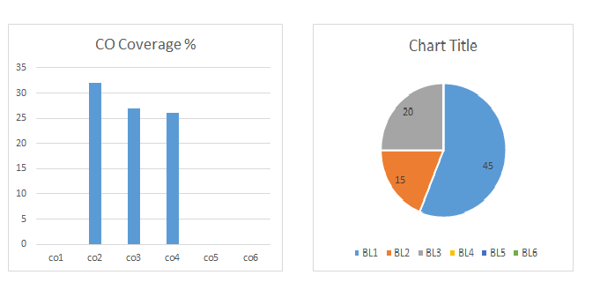

Approved by the Audit Professor/Course Coordinator

